Nottingham Orienteering Club
Junior Club Rules

The Club believes that it is important that members, coaches, administrators and parents associated with the Club should, at all times, show respect for each other, be encouraged to be open at all times and to share any concerns or complaints that they may have about any aspect of the Club with the Designated Officer:

Hilary Palmer: 0115 9820651

or the British Orienteering Designated Officer: Mike Hamilton Tel: 01629 734042

As a member of the Nottinghamshire Orienteering Club you are expected to follow these junior club rules:

Compete within the rules and respect officials and their decisions.

Respect your opponents.

Try to keep to agreed timings for training and competitions or inform your coach or team manager if you are going to be late.

Wear suitable kit for training and events, as agreed with the coach or team manager.

Remember to pay any fees for training or events promptly.

Do not smoke, or consume alcohol or drugs of any kind, at training sessions or when representing the Club in competitions.

It's important to follow these rules to make sure everyone can orienteer in a friendly and safe environment, as well as having fun!

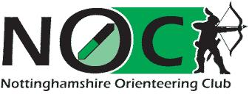
NOC Junior Rep

